Commodore CBM8296 Diagnostic: User Port Dongle Rev. 0  
Module Description

# Introduction

This User Port Dongle is part of the diagnostic clip set for the Commodore CBM8296. The original 324805-01 part incorporated a connector for the J4 memory expansion pin header. This dongle has a 2x5 box connector, which attaches to the J4 breakout board (project number 210) via a ribbon cable.

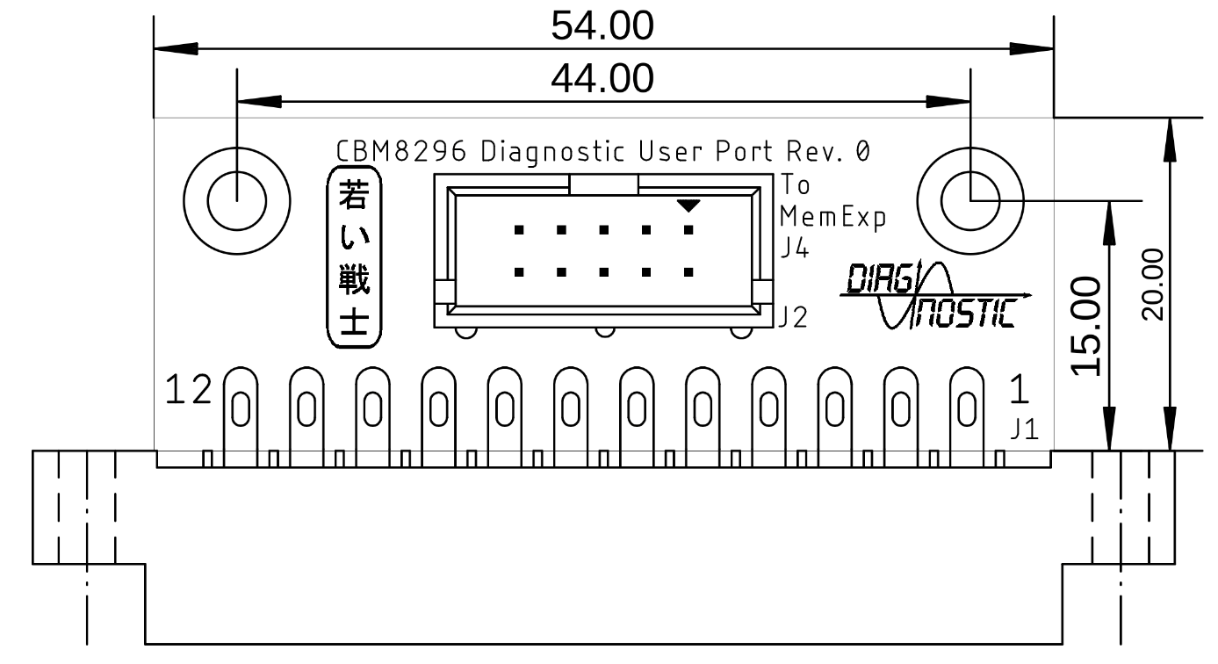

Figure 1: Dimensions of the User Port Dongle

# Connections

|  |  |
| --- | --- |
| Connection | Signals |
| B - M | CA1 - CB2 |
| C - J4.13 | PA0 - |
| D - J4.14 | PA1 - |
| E - J4.12 | PA2 - |

# Soldering The Edge Connector

To provide a defined position of the edge connector, it is recommended to solder it flat on the bottom side of the PCB. Then bending the top solder latches towards the board on the top side, so that a part lays flat. A suitable tool for this is a screw driver or tweezers. Finally soldering the latches to the top solder pads while holding them down until the solder joint has cooled down. It is best to do this before any through hole component is installed.

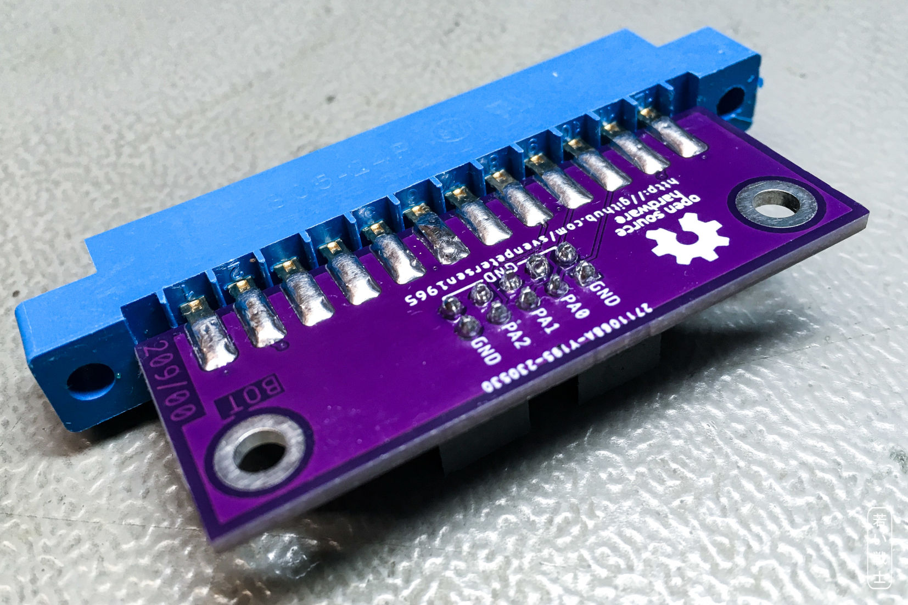

Figure 2: Step 1: Solder the bottom latches flat on the bottom side of the PCB

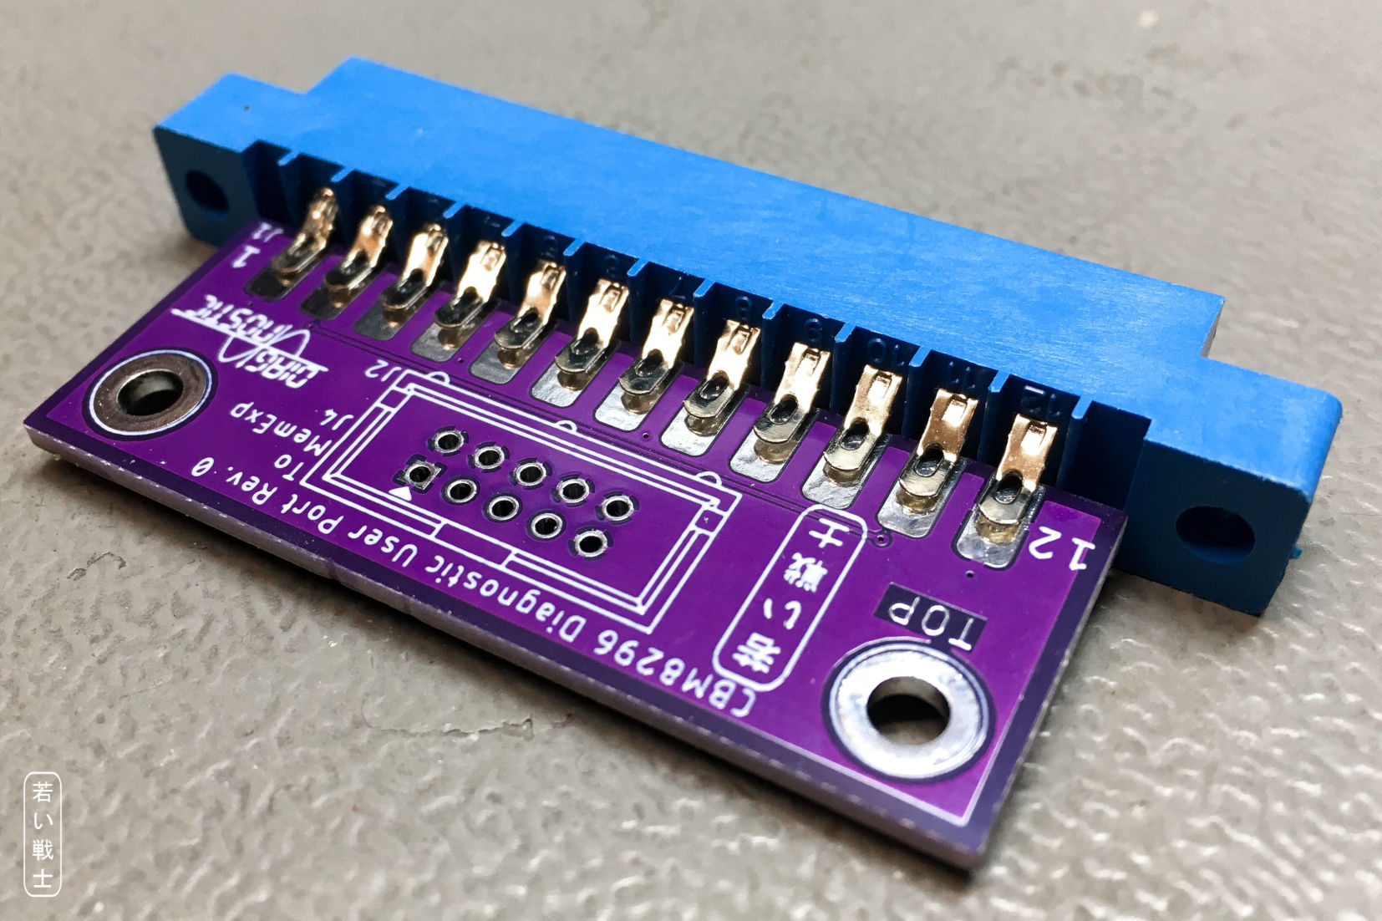

Figure 3: Step 2: The top latches are bent towards the PCB

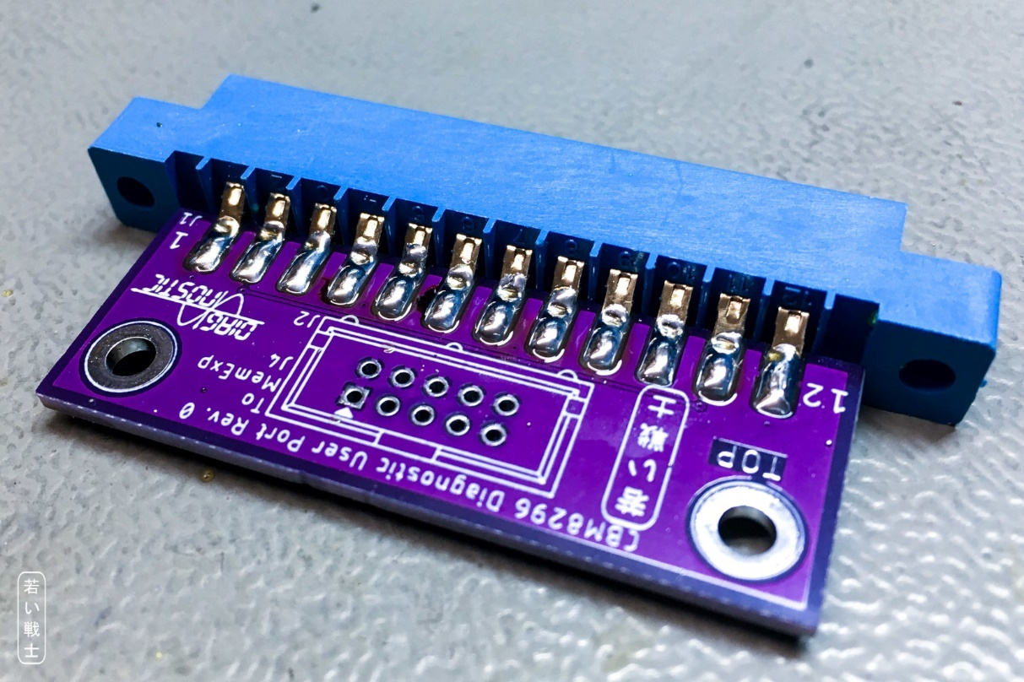

Figure 4: Step 3: The top latches are solder to the solder pads on the top side

# 3D-printed Case

The STL-files of the case are provided in the respective sub-folder of this project as is the label print.

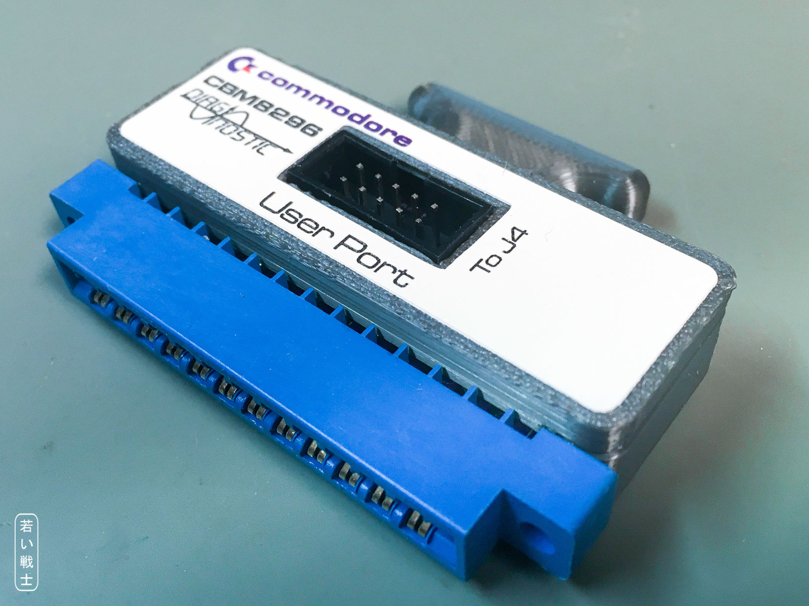

Figure 5: CBM8296 User Port dongle in a 3D printed case with label

Recommended screws: 2 each of C2.9x9.5 self-tapping screws for sheet metal (C 2,9x9,5H, DIN 7981).

# Revision History

## Rev. 0

* Prototype, not yet tested.